# Create Tile Server Table v1.10

The Tools Create Tile Server Table helps you create new MapInfo tables that load images from a Tile Server. MapInfo Pro has supported Tile Servers over a number of years, but you have until now had to create these yourself by creating a XML file manually or by creating the table using the MapBasic statement Create Table.

The Create Tile Server Table helps you setup the needed values for the Create Table statement and can then create the needed XML and Tab file that points at the tile server of your choice.

Once you have loaded the Create Tile Server Table add-in, you can access the Create Tile Server feature from the Open dropdown control on the Home, the Table and the Map tabs of the ribbon.

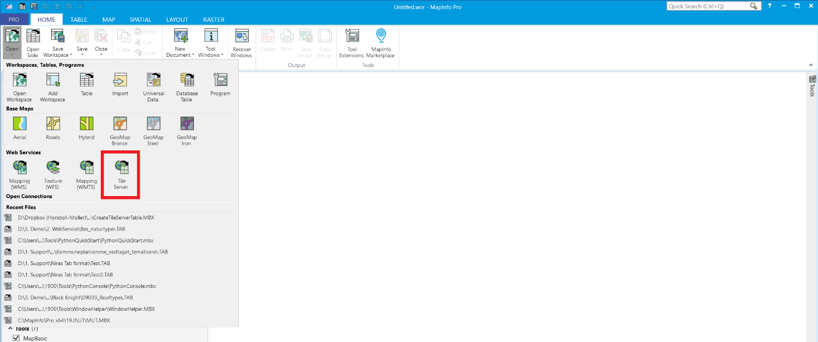

It is located next to the *Mapping (WMTS)* control in the *Web Service* section.

I would recommended that you open a vector map for the area that the Tile Server table will cover. When you create the tile server table through the *Create Tile Server Table* dialog, the add-in will open the table into the active map window – or into a new map window if you do not have any open. This gives you the option to validate that the result looks fine.

If the result does not look as expected, you can try to change some of the settings for the tile server table and recreate/overwrite the existing tile server table. In this way, you can try out multiple settings without having to reopen the *Create Tile Server Table* dialog continuously.

Click the *Tile Server* control to open the *Create Tile Server Table* dialog.

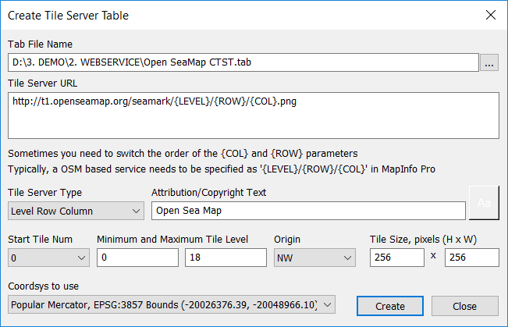

Here is how you can fill out the dialog.

**Tab File Name**: This is the name and path of the table that you afterwards can use to open the Tile Server Table when the add-in has created it.

**Tile Server URL**: Here you enter the URL that points towards the Tile Server. The structure of the URL depends on the Tile Server Type.

For the LevelRowColumn type, the URL must contain the three placeholders {LEVEL}, {ROW} and {COL}. At runtime, MapInfo Pro will replace these placeholders with the values calculated to fetch the appropriate tiles from the tile server to match the extent of the map window.

Servers support the {ROW} and {COL} tags differently; sometimes these tags may need to be reversed for row and column (or X, Y). Typically, an OSM based service needs to be specified as “{LEVEL}/{ROW}/{COL}”.

For the QuadKey type, the URL must contain the placeholder {QUADKEY}. At runtime, MapInfo Pro will replace this placeholder with the value calculated to fetch the appropriate tiles from the tile server to match the extent of the map window

**Tile Server Type**: This identifies the type of Tile Server you are connecting to:

* **QuadKey** - A server that uses a quad tree algorithm splits the world up into squares that are 256 pixels by 256 pixels. Each tile is referred to by a unique string of characters between 0 - 3 (QuadKey), which describes the position and zoom level at which to place the tile.
* **LevelRowColumn** - A server that splits the world up into squares where each tile identifier is a list containing the zoom level, row, and column number of the tile. The format of the tile identifier may vary from server to server, so the {ROW} and {COL} tags may seem reversed for some servers.

**Attribution/Copyright Text**: This text will be shown in the lower left side of the map. You can specify the text yourself. Often the provider of the service will tell you what attribution to use.

**Start Tile Number**: It is the number of the starting tile, either zero (0) or one (1). Zero (0) is the default start tile number.

**Minimum and Maximum Tile Level**: The minimum level for a tile server must be either zero (0) or a positive value and less than the maximum level. The default is zero (0). The maximum level must be a positive value and identifies maximum level the tile server supports.

**Origin**: This can only be one of the two values - "NW" or "SW". "SW" represents a South-West origin in which the tiles in the TileServer table are arranged in a bottom-up manner, starting from the lower-left corner. "NW" represents a North-West origin of the tiles, starting from the upper-left corner. "NW" is the default value.

**Tile Size, pixel (H * W)**: This sets the size of the tiles that the tile server will return. It is the size in pixels of a single tile from the tile server. These must be positive values. If the width is not specified, the height is used as the width. This value is typically 256 pixels.

**CoordSys to Use**: here you can select the coordinate system to use for the tile service. Most tile servers are using the Popular Mercator coordinate system. For that, it is recommended to use the first Popular Mercator coordinate system in the list.

The difference between the three Popular Mercator coordinate systems is the bounds. We have seen different bounds for different services.

You can manually add another coordinate system and set of bounds to the application by adding these to the CreateTileServerTable.ini file that is located in the folder where the application has been installed.

Here are the existing coordinate systems in the file. The two highlighted examples are using the same coordinatesystem British National Grid.

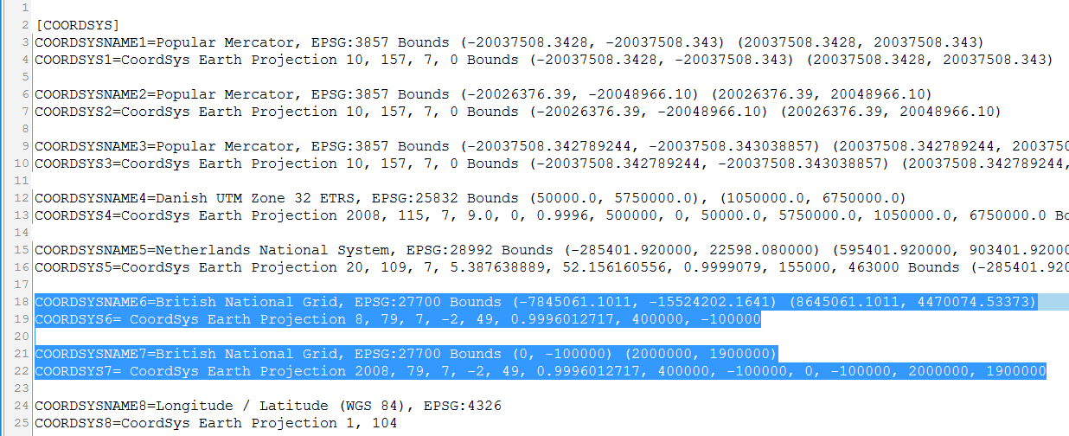

Notice how they are using the same number after COORDSYSNAME and COORDSYS. That’s how the application knows how to link the two elements, the name and the coordsys parameters. The coordsys parameters can also include bounds. For the two British National Grid coordinate systems, the second is using some more narrow bounds around the British Isles.